From: Don

To: The Record

Subject: Hostek Configuration for BBSG (see emails from Hostek on 5/3/2015 for “official” details

Date: 7/25/2018

Hostek run on LUCEE. Donport runs on LUCEE. The box command server start uses, say, bbsgdv1/server-bbsgdv1.json, OR go.boxr provides arguments to “server start” explicitly. Server-bbsgdv1.json defines that we use Lucee, and the port number, e.g. 56801. The data source is then mapped from the incoming URL, as defined in config/Coldbox.cfc. The datasource definitions there must be consistent with the DSN’s in Lucee!

Link to Hostek Mocha control panel is: <https://wcp.hostek.com/Login.aspx>

Link to lucee. Note the locations of files for web contexts.

<http://216.15.141.160:8888/lucee/admin/server.cfm>

Quick MySQL note about setting up databases. To copy the ltdv1 schema/database from Donport4 to Hostek **ltdv1h,** use Navicat. Ltdv1h must already exist. It is created in MySQL workbench running on Donport4, by adding a connection. Password is .Nogo123

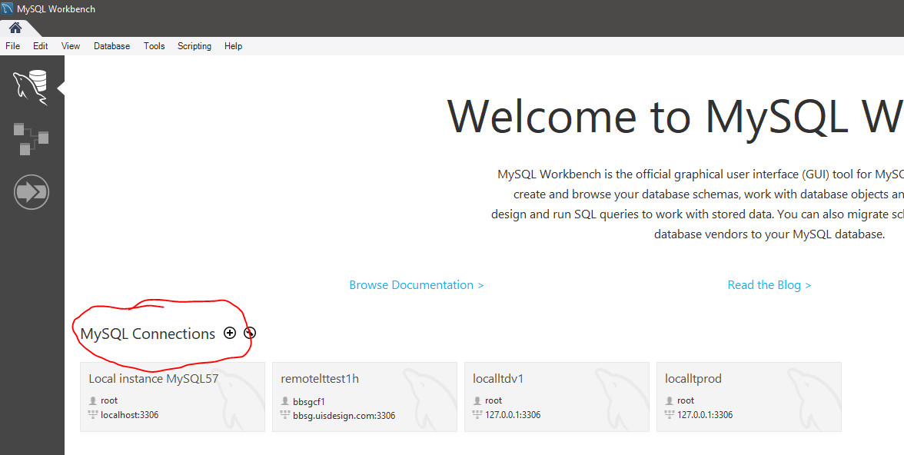

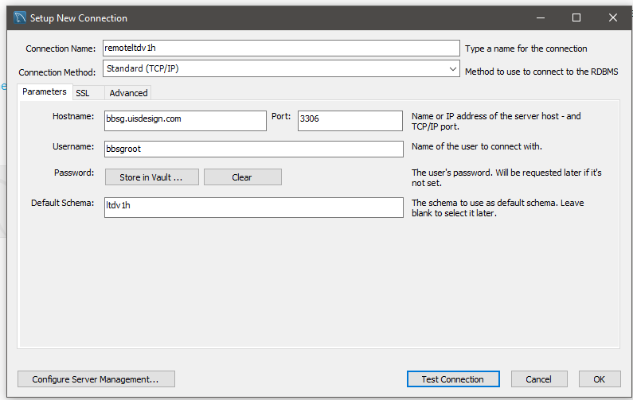

Here is the Navicat transfer. BE CAREFUL you are going to ldtv1h.

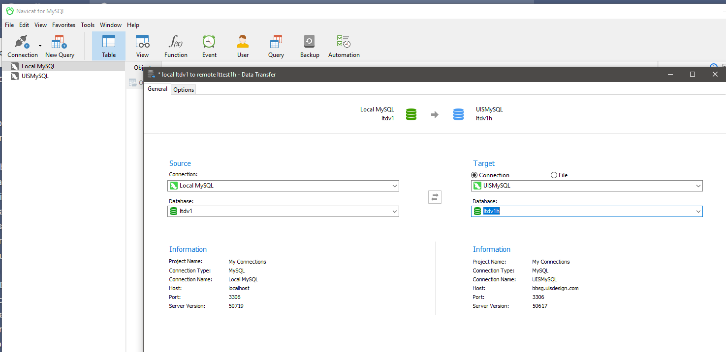

MySQL databases are in C:\Program**Data**\MySQL\MySQL Server 5.6\data\...

See “Server Instance DataBase DSN.xlsx” for details on DSN’s in all formats and locations

After logging into Hostek Mocha Control Panel. In domain: uisdesign, Click on MySQL within Databases. In this case, LTdv1 is obsolete, and will be deleted.

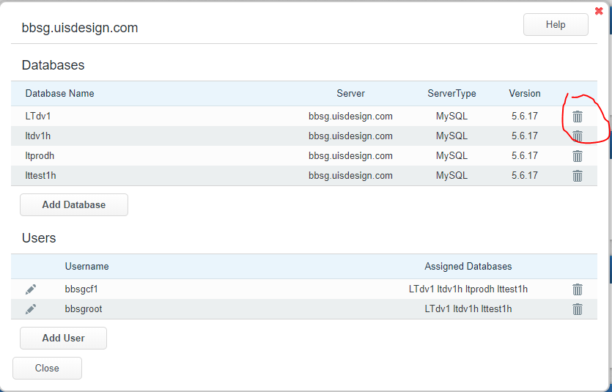

Here are Datasources

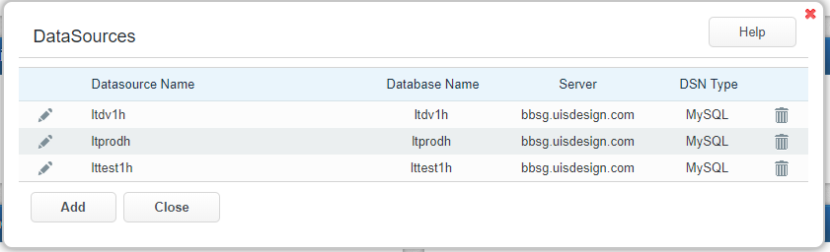

Here is detail about ltdv1h

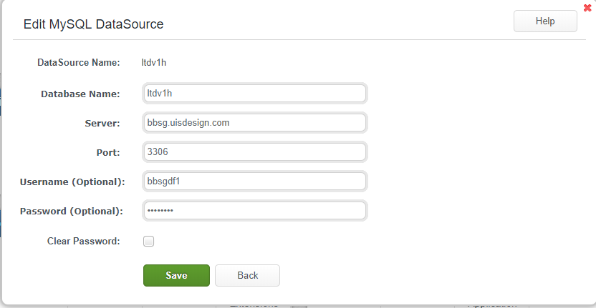

Here is link to the development application, in a subdomain: <http://dev.uisdesign.com/?fwreinit=1>

Here are subdomains

Here are subdomains. We will add “prod”.

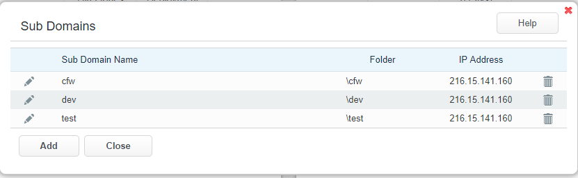

And detail on dev

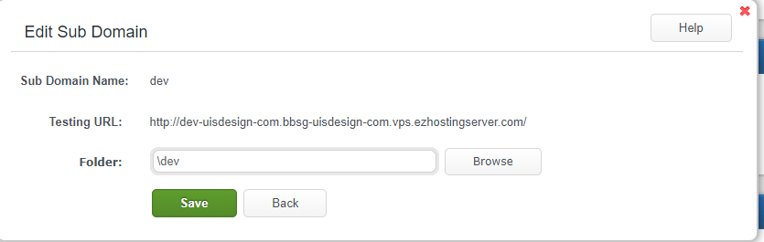

Here are virtual directories. We will add Prod.

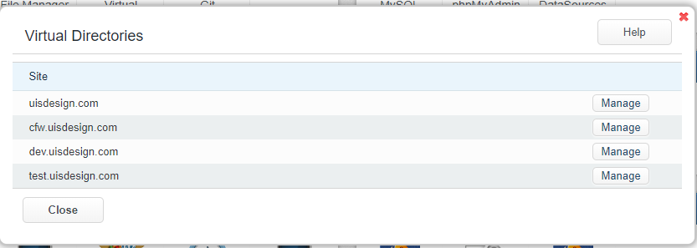

There is no detail under here.

Here is Lucee. Dev and test are subdomains. The production is without a subdomain. The code is in home/usidesign.com/wwwroot

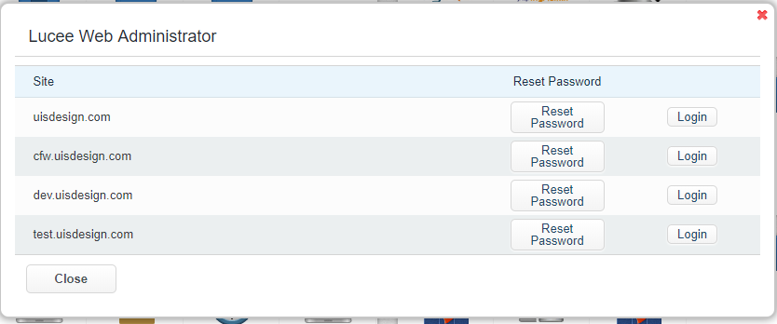

Here is the SERVER level information from Lucee

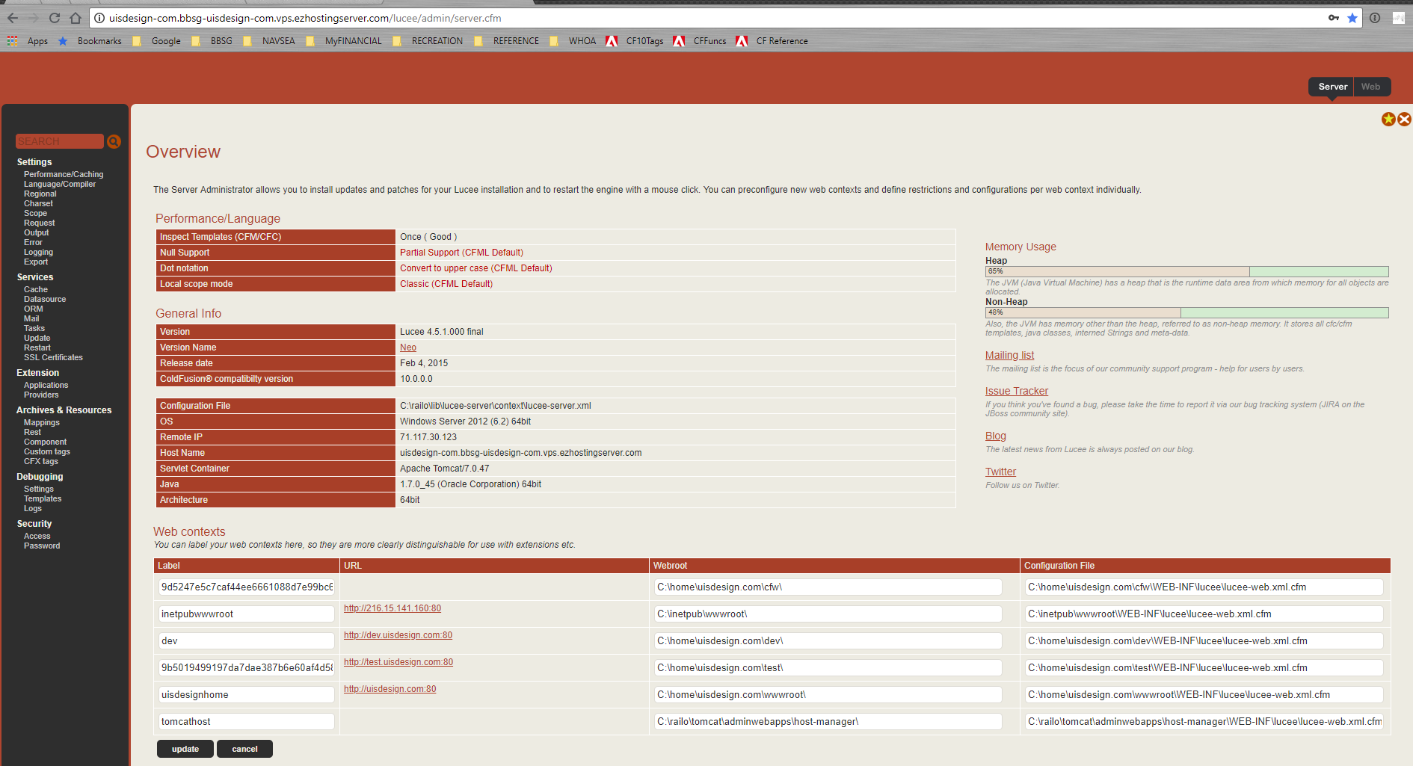Here is Mail

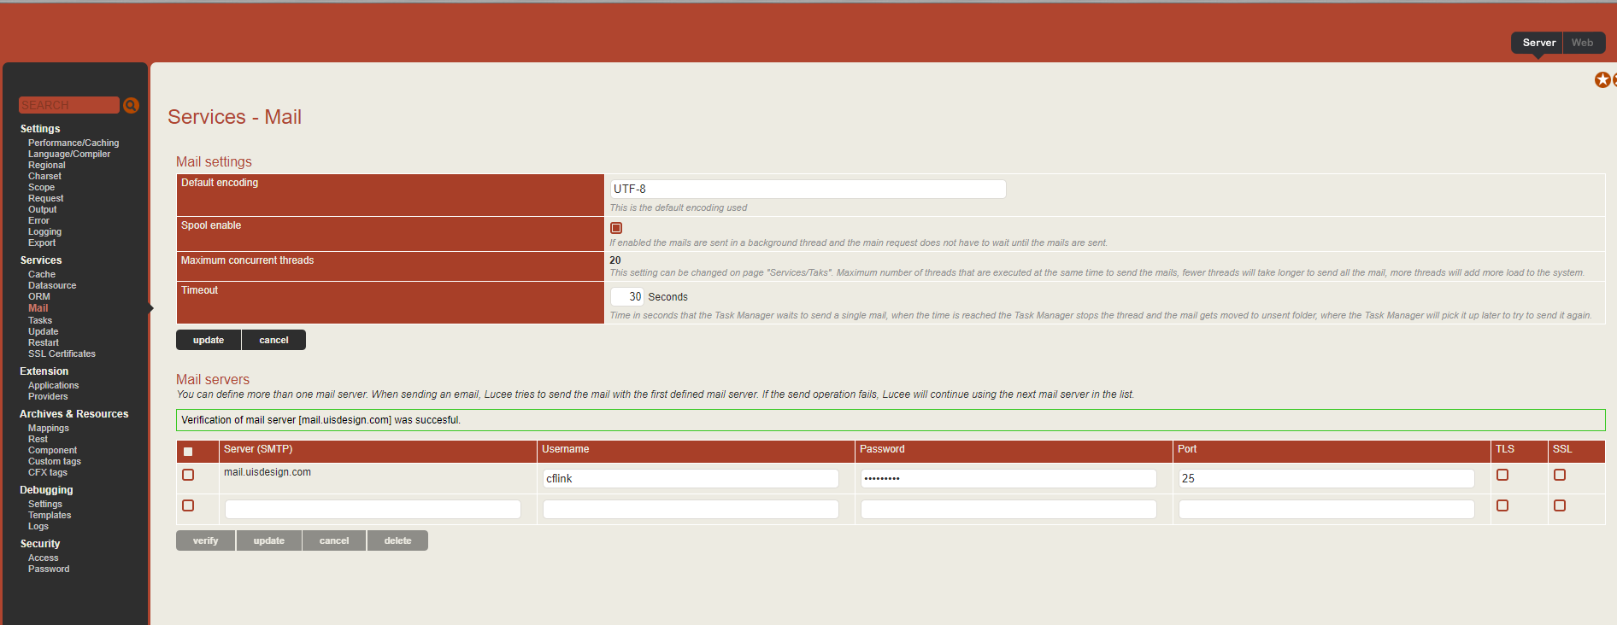

Here is the File Manager, for restoring files or bunches of files from “backup”.

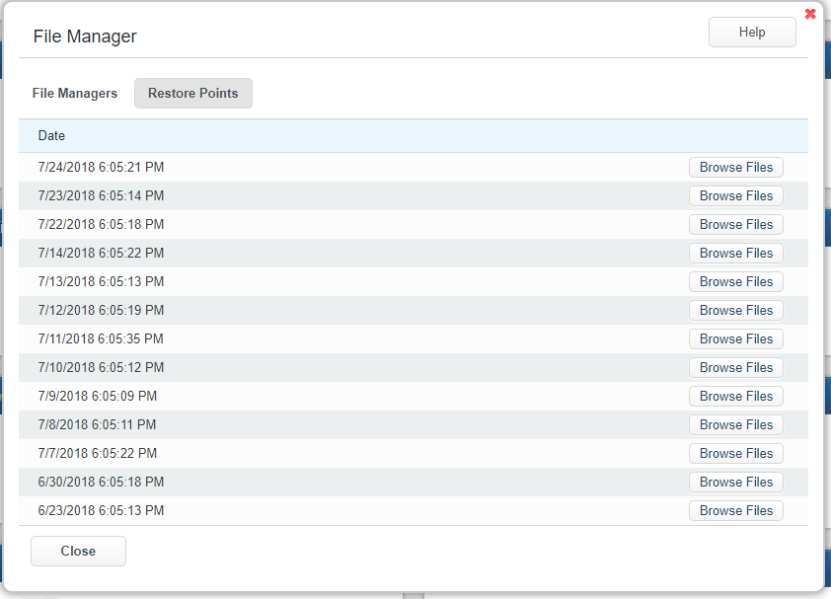

Instead of File Manager, we keep our source code on git, in belldrfree.

Code is uploaded from Donport4 to belldrfree, the dev branch.

Use remote desktop on Hostek, using tortoise git to do a pull.

TortoiseGit Origin points to <https://github.com/belldrfree/uisdesign-dv1.git>, just like on donport4

Putty Key is C:\Users\Administrator\Documents\.ssh\putty_private.ppk

Navigate to C:\home\uisdesign.com

Right-click on dev, be sure you are on the dev branch, then pull.